100 Swansea University Taught Master's Excellence Scholarships for UK/EU Students in UK, 2019
Swansea University, UK
Application Deadline: July 12, 2019
Apply Now

Jacobs Foundation Research Fellowship Program for Overseas Scholars in Germany, 2019
Jacobs Foundation, Germany
Application Deadline: March 17, 2019
Apply Now

MORE SCHOLARSHIPS

IWC Masters International Scholarships in Australia, 2019
International Water Centre, Australia
Application Deadline: August 1, 2019
Apply Now

Strathclyde Prestige Award for Excellence in Interdisciplinary English Studies 2019
University of Strathclyde, UK
Application Deadline: May 31, 2019
Apply Now

Griffth University International Student Excellence Scholarship–Postgraduate Coursework in Australia, 2019
Griffith University, Australia
Application Deadline: May 17, 2019
Apply Now

IFA Postgraduate Scholarships for French and International Students, 2019
International Fashion Academy
Application Deadline: March 15, 2019
Apply Now

Postdoctoral Fellowships for French and Overseas Applicants at CEMEF in France, 2019
Centre for Material Forming (CEMEF), France
Application Deadline: Applications are open to doctors from both France and overseas
Apply Now

50 Melbourne International Undergraduate Scholarships in Australia, 2019
University of Melbourne, Australia
Application Deadline: No application is required
Apply Now

Postgraduate Taught Scholarships for International Students at Birmingham Business School in UK, 2019
University of Birmingham, UK 28
Application Deadline: April 2019
Apply Now

E4D Continuing Education Scholarship for Candidates from Low-Income Countries in Switzerland, 2019
Eidgenössische Technische Hochschule Zürich (ETH Zurich), Switzerland
Application Deadline: April 30, 2019
Apply Now

Goldsmiths University of London Scholarships for Masters Programme in UK, 2019
Goldsmiths University of London, UK
Application Deadline: June 30, 2019
Apply Now

MBA Scholarships for International Students at the University of Glasgow in UK, 2019
University of Glasgow, UK
Application Deadline: March 1, 2019
Apply Now

Austrian Development Cooperation ITH Scholarships for Developing Countries, 2019
Austrian Development Cooperation, Austria
Application Deadline: May 1, 2019
Apply Now

Prem Tinsulanonda International School Scholarships in Thailand, 2019
Prem Tinsulanonda International School, Thailand
Application Deadline: March 17, 2019
Apply Now

2019 International IGB Fellowship Programme for Research in Freshwater Science, Germany
Leibniz-Institute of Freshwater Ecology and Inland Fisheries (IGB), Germany
Application Deadline: June 1, 2019
Apply Now

SLS Excellence Scholarships for International Students at the University of Warwick in UK, 2019
University of Warwick, UK
Application Deadline: May 30, 2019
Apply Now

Ruth First Scholarship for Taught Master's Degree Program at Durham University in UK, 2019-20
Durham University, UK
Application Deadline: March 1, 2019
Apply Now

Latvian Government Scholarships for Summer Schools, 2019
State Education Development Agency (Latvian Government), Latvia
Application Deadline: April 1, 2019
Apply Now

International Health Fellowship at the St George's University of London in UK, 2019
St George’s University of London, UK
Application Deadline: March 31st, 2019
Apply Now

Kirby Laing International Scholarships at the University of Edinburgh in UK, 2019
University of Edinburgh, UK
Application Deadline: April 2, 2019
Apply Now

Scholarships for International HAW Hamburg Master Students in Germany, 2019
Hamburg University of Applied Sciences, Australia
Application Deadline: April 30, 2019
Apply Now

International Scholarships for Masters Programme at the University of Essex in UK, 2019
University of Essex, England
Application Deadline: September 13, 2019
Apply Now

St Mary’s International Student Scholarships in UK, 2019-2020
St Mary’s University, UK
Application Deadline: Open for 2019.
Apply Now

International Business Scholarships at the University of Technology Sydney in Australia, 2019
University of Technology Sydney, Australia
Application Deadline: April each year
Apply Now

Brunei Darussalam Government Scholarships for Foreign Students, 2019
Ministry of Foreign Affairs, Brunei Darussalam
Application Deadline: February 28, 2019
Apply Now

Foundation Scholarships for Australian Students at Federation University, 2019
Federation University, Australia
Application Deadline: February 22, 2019
Apply Now

Vice-Chancellor’s International Scholarships at the University of Sydney in Australia, 2018-19
University of Sydney, Australia
Application Deadline: March 29, 2019
Apply Now

Diploma Scholarships for Tanzanian Students at International School Moshi, 2019
International School Moshi (ISM), Tanzania
Application Deadline: February 20, 2019
Apply Now

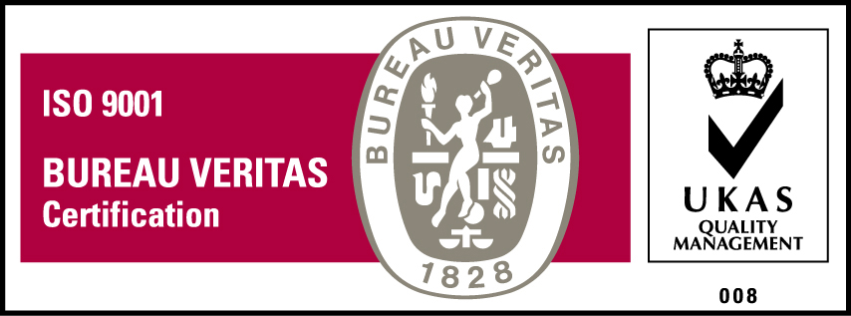
KyU is ISO 9001:2015 Certified

