KIRINYAGA UNIVERSITY

SCHOLARSHIP OPPORTUNITIES
Emile-Boutmy Scholarship for International Students in France, 2017-2018
European Union, France
Application Deadline: January 13, 2017
Apply Now
Massachusetts Institute of Technology Free Online Course On Building Mobile Apps
Massachusetts Institute of Technology
Course starts March 7, 2017
Apply Now
Berlin International Graduate School PhD Award in Germany, 2017
Berlin International Graduate School in Model and Simulation based Research (BIMoS), Germany
Application Deadline: February 17, 2017
Apply Now
International Joint MSc Scholarships for Developing Countries in Germany, 2017
United Nations University in Bonn, Germany
Application Deadline: January 15, 2017
Apply Now
International Flagship Undergraduate Scholarships at University of Maine in USA, 2017
University of Maine, United States of America
Application Deadline: February 1, 2017
Apply Now
Academic Excellence Scholarships (AES) at La Trobe University in Australia, 2017
La Trobe University, Australia
Application Deadline: November 6, 2017
Apply Now
35 Doctoral Scholarships at Victoria University of Wellington, 2017-2018
Victoria University, New Zealand
Application Deadline: March 1, 2017
Apply Now
Hungarian Government Scholarship Programme for Developing Countries, 2017-2018
Ministry of Agriculture of Hungary, Hungarian Government, Hungary
Application Deadline: February 28, 2017
Apply Now
Data Structures Free Online Course by University of Adelaide
University of Adelaide, Australia
Course Starts on March 21, 2017
Apply Now
Novo Nordisk Internship in Marketing for International Students in Denmark, 2017
Application Deadline January 22, 2017
Apply Now
Bachelor of Computer Science Program Scholarship for International Students at Griffith University in Australia, 2017
Griffith University in Australia
Application Deadline: February, 26, 2017.
Apply Now
GMAT Scholarships for International Students in Germany, 2017
ESMT Berlin, Germany
Application Deadline: March 31, 2017
Apply Now
Online Course on Cyberwar, Surveillance and Security
The University of Adelaide, Australia
Self-Paced
Apply Now
JFUNU Scholarship for Developing Countries in Japan, 2017
Japan Foundation for UNU (JFUNU), Japan
Application Deadline: April 28, 2017
Apply Now
University of Boras Scholarships for International Students in Sweden, 2017
University of Boras, Sweden
Application Deadline: February 1, 2017
Apply Now
University of Westminster Scholarships for International Students in UK, 2018
University of Westminster, United Kingdom
Application Deadline: October 13, 2017
Apply Now
Urbanism Studies Scholarships for International Students in Sweden, 2017
KTH Royal Institute of Technology, Sweden
Application Deadline: January 16, 2017
Apply Now
UH Hilo International Student Scholarship for Undergraduates in USA, 2017-2018
University of Hawai'i at Hilo, United States of America
Application Deadline: March 15, 2017
Apply Now
African Young Water and Sanitation Professionals (AfYWSP) Scholarships in West Africa, 2017
African Water Association, West Africa
Application Deadline: February 28, 2017
Apply Now
10 Fully-Funded University of Nottingham PhD Studentships in Computer Science, UK
University of Nottingham, United Kingdom
Application Deadline: January 22, 2017
Apply Now
PhD Scholarship in Synthetic Biology at Tianjin University in China, 2017
Tianjin University in China
Application Deadline: January, 31, 2017
Apply Now
University College London Scholarships for Undergraduate Programme in UK, 2017
University College London, United Kingdom
Application Deadline: July 7, 2017
Apply Now
50 UWI Scholarships for Undergraduate Students at University of the West Indies in Jamaica, 2017
University of West Indies
Application Deadline: April 28, 2017
Apply Now
UNIDROIT Research Scholarships for International Students in Italy, 2017
International Institute for the Unification of Private Law (UNIDROIT)
Application Deadline: October 27, 2017
Apply Now
Achiever MBA Scholarships for International Students at UCD in Ireland, 2017
UCD Michael Smurfit Graduate Business School, Ireland
Application Deadline: March 31, 2017
Apply Now
Pompeu Fabra University DTIC PhD Fellowships in Spain, 2017-2018
Department of Information and Communication Technologies at Universitat Pompeu Fabra
Application Deadline: January 16, 2017
Apply Now
Pauline Graham Scholarship for African Women at LSE in UK, 2017
The London School of Economics and Political Science (LSE), United Kingdom
Application Deadline: April 26, 2017
Apply Now
Advancing Development Goals International Contest for Graduate Students, 2017
Graduate Institute of International and Development Studies, Geneva
Application Deadline: 31st July 2017
Apply Now
2017 Global Excellence PhD Scholarships for Armenian Students, Abroad
The Armenian Communities Department of the Calouste Gulbenkian Foundation
Application Deadline: February 28, 2017
Apply Now
2017 Great Britain Scholarships for Indian Students in UK
British Council
Application Deadline: Varies
Apply Now
Harvard South Africa Fellowship Program for South Africans in USA, 2018-2019
Harvard University Center for African Studies, United States of America
Application Deadline: February 28, 2017
Apply Now
Dr. APJ Abdul Kalam Summer Training Program in India, 2017
Academy of Scientific and Innovative Research (AcSIR), India
Application Deadline: January 13, 2017
Apply Now
PhD Scholarships: Indigenous Counselling and Nicotine (ICAN) QUIT in Pregnancy, Australia, 2017
University of Newcastle, Australia
Application Deadline: January 31, 2017
Apply Now
Merit Scholarships for Lebanese Students at Lebanese American University, 2017
Lebanese American University
Application Deadline: January 31, 2017
Apply Now
Postgraduate Scholarship for Students of Hong Kong at University of Birmingham in UK, 2017
University of Birmingham in Uk
Application Deadline: March, 31, 2017
Apply Now
Faculty of Humanities and Social Sciences PhD Studentships at Oxford Brookes University in UK, 2017
Oxford Brookes University, United Kingdom
Application Deadline: February 21, 2017
Apply Now
China Scholarship Council-University of Padova Scholarships for Chinese Students in Italy, 2017
University of Padova, Italy
Application Deadline: January 16, 2017
Apply Now
UNFCCC’s Internship Programme in Germany, 2017
Application Deadline Contact Employer
Apply Now
Google Business Internship for International Students in Singapore, 2017
Application Deadline February 28, 2017
Apply Now
Fully-funded Global Exchange Program in Film Industry in Vietnam, Spring 2017
Application Deadline January 12, 2017
Apply Now
Supply Chain Management Free Online Course by UCL
Université catholique de Louvain (UCL)
Course Starts on February 22, 2

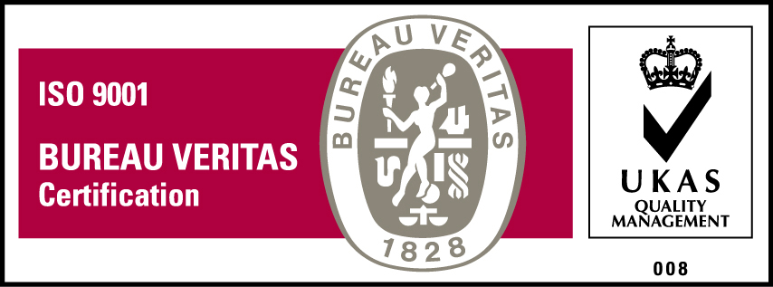
KyU is ISO 9001:2008 Certified

