|  |  |  |  |  |  |  |  |
| --- | --- | --- | --- | --- | --- | --- | --- |
| |  |  |  |  |  |  |  | | --- | --- | --- | --- | --- | --- | --- | | **KIRINYAGA UNIVERSITY**  **SCHOLARSHIP OPPORTUNITIES**   |  |  |  |  |  |  | | --- | --- | --- | --- | --- | --- | | |  |  |  |  | | --- | --- | --- | --- | | |  | | --- | | Kenya Scholarship Positions | | |  | | --- | |  | |   [**Master Card Foundation – RUFORUM Scholarships for Kenyan Students, 2018**](http://scholarship-positions.com/mcf-ruforum-scholarships-ugandan-kenyan-students/2017/08/29/) MasterCard Foundation Application Deadline: March 16, 2018 [**Apply Now**](http://scholarship-positions.com/mcf-ruforum-scholarships-ugandan-kenyan-students/2017/08/29/)[**Doctoral Dissertation Completion Fellowship for Africans Students, 2017**](http://scholarship-positions.com/doctoral-dissertation-completion-fellowship-for-africans-students/2017/09/12/) Social Science Research Council, USA Application Deadline: November 17, 2017 [**Apply Now**](http://scholarship-positions.com/doctoral-dissertation-completion-fellowship-for-africans-students/2017/09/12/)  [**Australia Awards Postdoctoral Fellowships for Africans, 2018**](http://scholarship-positions.com/australia-awards-postdoctoral-fellowships-africans-australian-government/2017/09/19/) Australian Government Application Deadline: November 30, 2017 [**Apply Now**](http://scholarship-positions.com/australia-awards-postdoctoral-fellowships-africans-australian-government/2017/09/19/)[**ILRI PhD Graduate Fellowship in Kenya, 2017**](http://scholarship-positions.com/ilri-phd-graduate-fellowship-kenya/2017/09/16/) International Livestock Research Institute, Kenya Application Deadline: September 22, 2017 [**Apply Now**](http://scholarship-positions.com/ilri-phd-graduate-fellowship-kenya/2017/09/16/)[**ILRI Postdoctoral Position for International Scientist in Kenya, 2017**](http://scholarship-positions.com/ilri-post-doctoral-position-international-scientist-kenya/2017/08/26/) International Livestock Research Institute, Kenya Application Deadline: September 18, 2017 [**Apply Now**](http://scholarship-positions.com/ilri-post-doctoral-position-international-scientist-kenya/2017/08/26/)  [**2018 Korean Government Scholarship Program for International Graduate Students**](http://scholarship-positions.com/2014-korean-government-scholarship-program-international-students-korea/2014/03/05/) Korean government Application Deadline: October-November in the year prior to planned studies in Korea [**Apply Now**](http://scholarship-positions.com/2014-korean-government-scholarship-program-international-students-korea/2014/03/05/)  [**MPhil Scholarships for Developing Countries at University of Cambridge in UK, 2018-2019**](http://scholarship-positions.com/mphil-scholarships-developing-countriesuniversity-of-cambridge-uk/2016/09/03/) University of Cambridge, United Kingdom Application Deadline: December 6, 2017 [**Apply Now**](http://scholarship-positions.com/mphil-scholarships-developing-countriesuniversity-of-cambridge-uk/2016/09/03/)  [**2018 Fully Funded Fellowships for United Nations Regional Courses in International Law, Ethiopia**](http://scholarship-positions.com/fully-funded-fellowships-united-nations-regional-courses-international-law-ethiopia/2017/09/16/) Addis Ababa University, Ethiopia Application Deadline: October 20, 2017 [**Apply Now**](http://scholarship-positions.com/fully-funded-fellowships-united-nations-regional-courses-international-law-ethiopia/2017/09/16/)  [**Richard Van Loon Scholarships for African Students at Carleton University in Canada, 2017-2018**](http://scholarship-positions.com/richard-van-loon-scholarships-african-students-carleton-university-canada/2017/09/12/) Carleton University in Canada Application Deadline: November 15, 2017 [**Apply Now**](http://scholarship-positions.com/richard-van-loon-scholarships-african-students-carleton-university-canada/2017/09/12/)  [**MPH Scholarships for African and Latin American Countries in Bangladesh, 2017-2018**](http://scholarship-positions.com/mph-scholarships-african-latin-american-countries-bangladesh-2017-2018/2017/09/07/) Brac University, Bangladesh Application Deadline: November 1, 2017 [**Apply Now**](http://scholarship-positions.com/mph-scholarships-african-latin-american-countries-bangladesh-2017-2018/2017/09/07/)  [**EDCTP-AREF Preparatory Postdoctoral Fellowships for African Scientists, 2017**](http://scholarship-positions.com/edctp-aref-preparatory-fellowships/2017/08/11/) European & Developing Countries Clinical Trials Partnership (EDCTP) Application Deadline: October 13, 2017 [**Apply Now**](http://scholarship-positions.com/edctp-aref-preparatory-fellowships/2017/08/11/)  [**Deakin University’s STEM Scholarships in Australia, 2018**](http://scholarship-positions.com/deakin-universitys-stem-scholarships-australia/2017/07/15/) Deakin University, Australia Application Deadline: November 6, 2017 [**Apply Now**](http://scholarship-positions.com/deakin-universitys-stem-scholarships-australia/2017/07/15/)  [**Miles Morland Foundation Morland Writing Scholarships for African Writers, 2017**](http://scholarship-positions.com/miles-morland-foundation-morland-writing-scholarships-african-writers/2017/07/01/) Miles Morland Foundation, Africa Application Deadline: October 31, 2017 [**Apply Now**](http://scholarship-positions.com/miles-morland-foundation-morland-writing-scholarships-african-writers/2017/07/01/)  [**Wenner-Gren Foundation Fully funded PhD Fellowships for African Students, 2017**](http://scholarship-positions.com/wenner-gren-foundation-fully-funded-phd-fellowships-african-students/2017/06/27/) Wenner-Gren Foundation, South Africa Application Deadline: December 15, 2017 [**Apply Now**](http://scholarship-positions.com/wenner-gren-foundation-fully-funded-phd-fellowships-african-students/2017/06/27/)  [**Full Tuition Fees MTN Solution Space Masters Scholarships in South Africa, 2017**](http://scholarship-positions.com/full-tuition-fees-mtn-solution-space-masters-scholarships-south-africa/2017/06/02/) University of Cape Town, South Africa Application Deadline: October 31, 2017 [**Apply Now**](http://scholarship-positions.com/full-tuition-fees-mtn-solution-space-masters-scholarships-south-africa/2017/06/02/)  [**Africa Scholarship Programme for Postgraduate Programme at University of Essex in UK, 2017**](http://scholarship-positions.com/africa-scholarship-programme-postgraduate-programme-university-essex-uk/2017/05/06/) University of Essex, United Kingdom Application Deadline: September 30, 2017 [**Apply Now**](http://scholarship-positions.com/africa-scholarship-programme-postgraduate-programme-university-essex-uk/2017/05/06/)[**ESPE Clinical Research Fellowship Program in UK, 2017**](http://scholarship-positions.com/espe-clinical-research-fellowship-program-uk/2017/09/16/) The European Society of Paediatric Endocrinology Application Deadline: May 31 each year [**Apply Now**](http://scholarship-positions.com/espe-clinical-research-fellowship-program-uk/2017/09/16/)  [**UTAMU 10 Masters Scholarships in Uganda, 2017**](http://scholarship-positions.com/utamu-masters-scholarships-uganda/2017/07/31/) Uganda Technology and Management University Application Deadline: October 10, 2017 [**Apply Now**](http://scholarship-positions.com/utamu-masters-scholarships-uganda/2017/07/31/) | |  | | | |

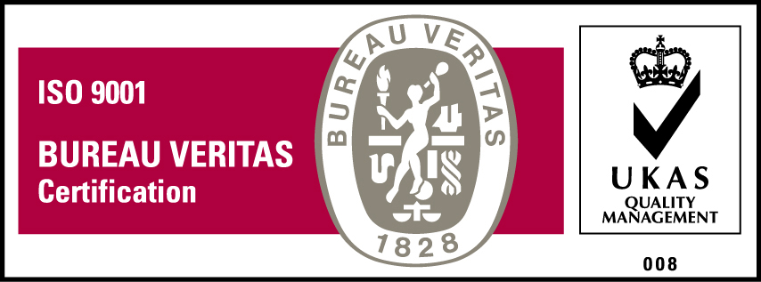***KyU is ISO 9001:2015 Certified***