foundation of the Republic of Austria International Scholarships, 2018
Scholarship Foundation of the Republic of Austria
Application Deadline: September 1, 2018
Apply Now
Qingdao Government Scholarships for New International Students in China, 2018
China University of Petroleum
Application Deadline: July 1, 2018
Apply Now
Cardiff University Vice-Chancellor’s for International Students in UK, 2018
Cardiff University, United Kingdom
Application Deadline: August 24, 2018
Apply Now
24 Scholarships for Foreign Students at Sapienza University of Rome in Italy, 2018
Sapienza University of Rome, Italy
Application Deadline: June 11, 2018
Apply Now
University of Sussex Excellence Scholarships in UK, 2018-2019
University of Sussex, United Kingdom
Application Deadline: September 24, 2018
Apply Now
Matsumae International Foundation (MIF) Fellowship in Japan, 2019
The Matsumae International Foundation, Japan
Application Deadline: August 31, 2018
Apply Now
Biozentrum University of Basel International PhD Fellowship Program in Switzerland, 2018
Biozentrum University of Basel, Switzerland
Application Deadline: June 20, 2018
Apply Now
Salini Impregilo Full and Partial Master Scholarship in International Construction Management in Italy, 2018
Salini Impregilo, Italy
Application Deadline: v
Apply Now
School of Geographical and Earth Sciences Scholarships for International Students in UK, 2018
University of Glasgow, United Kingdom
Application Deadline: Open
Apply Now
PhD Scholarships in Economics and Statistics at University of Milan-Bicocca in Italy, 2019
University of Milan-Bicocca, Italy
Application Deadline: June 7, 2018
Apply Now
PhD Scholarship in Wind Energy and Society in Denmark, 2018
Technical University of Denmark
Application Deadline: June 3, 2018
Apply Now
PhD Fellowships in Natural Language Processing and Machine Learning, Denmark
University of Copenhagen, Denmark
Application Deadline: June 1, 2018
Apply Now
TSoM Love Canada Diploma Scholarship for International Students in Canada, 2018
The Toronto School of Management (TSoM), Canada
Application Deadline: Applications are open for the year 2018
Apply Now
CSU Master’s Degree Scholarship in Transportation Engineering for Non-Chinese Students in China, 2018
Central South University, China
Application Deadline: June 29, 2018
Apply Now
2018 OAS-NYIT Scholarship for Undergraduate and Graduate Programmes in New York, USA
New York Institute of Technology (NYIT), New York
Application Deadline: July 15, 2018
Apply Now
Guizhou University Special Exchange Scholarships in China, 2018
Guizhou University (GZU), China
Application Deadline: June 20, 2018
Apply Now
2018 PhD Scholarship in Data-driven Runtime Process Performance Improvement in the Netherlands
University of Groningen, Netherlands
Application Deadline: June 28 and June 29, 2018
Apply Now
3 PhD-Positions in Efficient Deep Learning at VU University Amsterdam in Netherlands, 2018
Vrije Universiteit Amsterdam, Netherlands
Application Deadline: May 24, 2018
Apply Now
50th Anniversary Scholarship for UK Postgraduate Students at University of Bradford, 2018
University of Bradford, United Kingdom
Application Deadline: July 25, 2018
Apply Now
DRB-HICOM International Student Scholarships in Malaysia, 2018
DRB-HICOM University of Automotive Malaysia
Application Deadline: Open
Apply Now

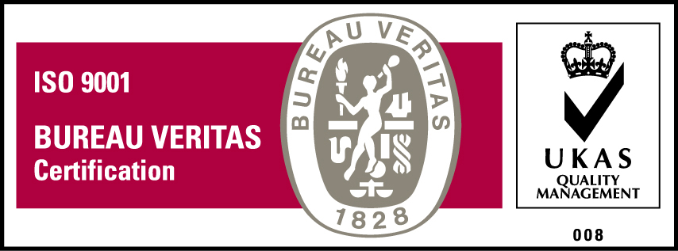
KyU is ISO 9001:2015 Certified

