|  |  |  |  |  |
| --- | --- | --- | --- | --- |
| |  |  |  |  | | --- | --- | --- | --- | | **SCHOLARSHIP OPPORTUNITIES**   |  |  |  | | --- | --- | --- | | |  | | --- | | British Chevening Scholarships for International Students | | **Deadline:** 7 Nov 2017 (annual) Study in: UK Course starts Sept/Oct 2018  **Brief description:**  Chevening Scholarships are the UK government’s global scholarship programme, funded by the Foreign and Commonwealth Office (FCO) and partner organisations. The programme offers awards to outstanding scholars with leadership potential from around the world to study for a master’s degree in any subject at any UK university.  **Host Institution(s):**  Any university in the UK  **Level/Field(s) of study:**  Full-time taught Masters Degree Programme in any subject at any UK university  **Number of Awards:**  Around 1500 scholarships globally will be offered.  **Target group:**  The scholarships are targeted to citizens of Chevening-eligible countries.  See the official website for complete list of countries eligible for Chevening scholarships.  **Scholarship value/inclusions:**  A Chevening Scholarship normally covers university tuition fees, a monthly stipend, travel costs to and from the UK, an arrival allowance, a homeward departure allowance, the cost of one visa application, and a travel grant to attend Chevening events in the UK.  **Eligibility:**  To be eligible for a Chevening Scholarship you must:  •  Be a citizen of a Chevening-eligible country.  •  Return to your country of citizenship for a minimum of two years after your scholarship has ended  •  Have an undergraduate degree that will enable you to gain entry to a post-graduate programme at a UK university. This is typically equivalent to an upper second-class 2:1 honours degree in the UK  •  Have at least two years’ work experience  •  Apply to three different eligible UK university courses and have received an unconditional offer from one of these choices by 12 July 2018  •  Meet the Chevening [English language requirement](http://www.chevening.org/apply/english-language-requirement) by 12 July 2018  **Application instructions:**  Applications for Chevening Awards can only be submitted using the Chevening online application system, available through the ‘apply’ button on your country’s page. Applications close on  **7 November 2017**at 12:00 GMT (midday UK time). | | | |

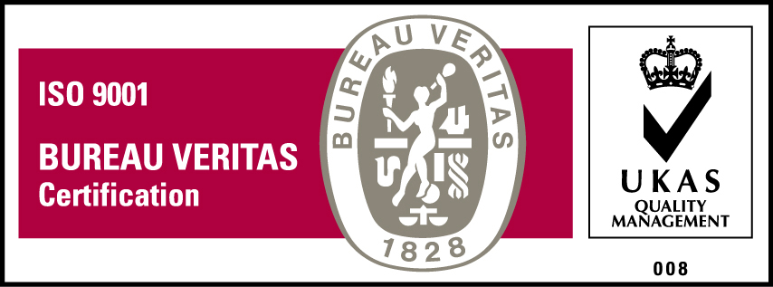***KyU is ISO 9001:2015 Certified***