University of Essex Africa Scholarship Programme in UK, 2018
University of Essex, United Kingdom
Application Deadline: September 30, 2018
Apply Now
UCC Quercus Taught Masters Academic Scholarships in Ireland, 2018
University College Cork, Ireland
Application Deadline: June 1, 2018
Apply Now
University of Portsmouth Faculty of Science Postgraduate Scholarships in UK, 2018
University of Portsmouth, United Kingdom
Application Deadline: July 6, 2018
Apply Now
Dean’s Award for Excellence in Research in UK, 2018
Loughborough University, United Kingdom
Application Deadline: July 31, 2018
Apply Now
ZEF’s Doctoral Scholarship Programme in Germany, 2018
University of Bonn, Germany
Application Deadline: August 31, 2018
Apply Now
University of Birmingham Foundation Academic Merit Scholarships in UK, 2018
University of Birmingham, United Kingdom
Application Deadline: August 6, 2018
Apply Now
Lt.Col Jack Wishart Scholarship for Postgraduate Students in UK, 2018-2019
University of Edinburgh, United Kingdom
Application Deadline: September 30, 2018
Apply Now
MBA Partial Fee Scholarships at Heriot-Watt University in Malaysia, 2018
Heriot-Watt University, Malaysia campus
Application Deadline: June 30, 2018
Apply Now
34th Cycle Doctoral Scholarships for Foreign Students at University of Trento in Italy, 2018
University of Trento, Italy
Application Deadline: May 31, 2018
Apply Now
University of Botswana MPhil and PhD Scholarships in the Faculty of Health Sciences in Botswana, 2018
University of Botswana
Application Deadline: May 31, 2018
Apply Now
CBS PhD Scholarships in Economic Rationalities for International Students in Denmark, 2018
Copenhagen Business School, Denmark
Application Deadline: August 1, 2018
Apply Now
Euromasters Scholarships for Overseas Students at University of Bath in UK, 2018
University of Bath, United Kingdom
Application Deadline: External Euromasters Scholarship: August 31, 2018 and Internal Euromasters Scholarship: June 30, 2018.
Apply Now
Free Online Course on Unethical Decision Making in Organizations
University of Lausanne
Course starts on May 28, 2018
Apply Now
Free Online Course on Organizational Design
Indian Institute of Management, Bangalore
Course will start on July 5, 2018
Apply Now
Harvard University Online Course to Learn Hinduism
Harvard University, United Stated of America
Course starts on June 4, 2018
Apply Now
Free Online Course on Buyer Behaviour and Analysis
Curtin University
Course Starts on September 17, 2018
Apply Now

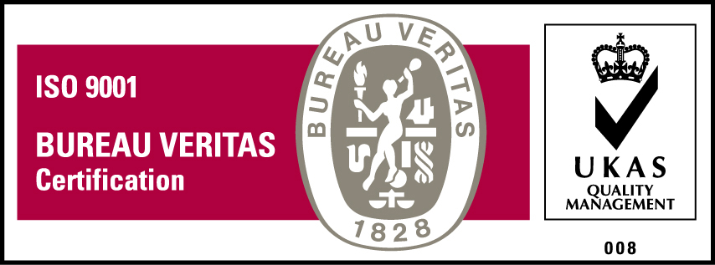
KyU is ISO 9001:2015 Certified

