|  |  |  |
| --- | --- | --- |
| |  |  | | --- | --- | | **SCHOLARSHIP OPPORTUNITIES**   |  | | --- | | Australia Government Scholarships for 10000 African Students 2018/2019 (Undergraduate and Graduate Studies) From 1st September, application opens for Australia Awards Scholarships 2017/2018. There are two categories of Award: **Australian Awards Scholarships**, to undertake higher degree studies in Australia at Masters level. And **Australia Awards Short Courses**, to undertake short-term, targeted professional training courses, in Australia and/or in Africa, in a range of development-focused sectors.  **Application Deadline:** 15th December, 2017 | Application for Short Courses closes **15th January, 2018**.  **Offered annually?** Yes  **Eligible Countries:**Algeria, Angola, Benin, Botswana, Burkina Faso, Burundi, Cameroun, Cape Verde, Comoros, Congo(Republic of), Djibouti, Egypt, Ethiopia, The Gambia, Ghana, Kenya, Lesotho, Liberia, Libya, Malawi, Mali, Mauritius, Morocco, Mozambique, Namibia, Nigeria, Rwanda, Sao Tome & Principe, Senegal, Seychelles, Sierra Leone, South Africa, Swaziland, Tanzania, Togo, Tunisia, Uganda, Zambia etc  In addition to the above, the following countries are eligible for Short Course Awards (SCAs)  Central African Republic, Chad, Comoros, Cote d’Ivoire, Democratic Republic of Congo, Equatorial Guinea, Gabon, Mauritania, Niger, North Sudan, Republic of Guinea, South Sudan  **To be taken at:** African or Australian Universities.  **Priority Fields (varies by African country)**   * Agriculture/Food Security * Education * Health * Public Policy (including public sector management, public sector reform, trade, international diplomacy) * Environmental Management * Natural Resource Management (including mining related subjects) * Technical and Vocational Education & Training (available for Short Courses only) * Energy (including Natural Gas and Oil Technology) * Infrastructure * Natural Resource Management * Transport (including Ports, Roads and Airports Management)   **About the Award:**Australia Awards, a cornerstone of the Australian Government’s development assistance program for Africa, provide access to postgraduate education, training and professional development opportunities for suitably qualified Africans from eligible countries. On their return to the workplace, Australia Awards Alumni are expected to contribute actively to development in their home countries.  [Apply for Bristol University International Office Scholarships for Undergraduate / Postgraduate Students 2017/2018](http://jobngn.com/apply-bristol-university-international-office-scholarships-undergraduate-postgraduate-students-20172018/)  **Offered Since:** 1980  **Type:** Masters taught degrees and short courses  **Eligibility**: Varies by country (see link below for specific country eligibility criteria)   * You must be at least 25 and not more than 50 years of age at the date of your application. * You must have at least three (3) years’ relevant post graduate work experience. This work experience must be in a role relevant to your proposed field of study and to your employment organization type (e.g. public sector applicants should demonstrate public sector work experience, and so on). Preference will be given to candidates with greater periods of experience. * You possess, as a minimum, a Bachelors degree (or the equivalent) from a recognized Institution of at least 4 years in length with at least a 3rd Class Pass. * Public sector candidates must comply with Government of Nigeria regulations for government employees wishing to apply for scholarships. * Public sector, private sector and civil society candidates must provide evidence of completion of the National Youth Service Corp (NYSC) when they apply. * You must not already hold, or be studying for, a Masters degree. * You must be willing to make a formal commitment to return to your current employment following completion of the award. * You must meet the general minimum eligibility criteria for Australia Awards Scholarships – refer to the Australia Awards Scholarships policy handbook.   **Target Group**   * You are a national of an African country. See country list below * You are an early or mid-career professional working in the Public Sector, the Private Sector or a Non-Government Organization (Civil Society) in one of the listed priority fields of study. * You wish to undertake a Masters degree in Australia in one of the listed priority fields of study. You cannot study a Masters of Business Administration. * You have a clear vision for how you will use the knowledge gained through the Masters degree to improve policy, practice or education in the proposed field of study. * Gender Equality: Australia Awards target equal participation by women and men. Applications from women are strongly encouraged, and mechanisms are in place to support women applicants and Awardees. * Disability Inclusion: Australia Awards aim to ensure that people with a disability are given fair and equal opportunity to compete for and obtain a scholarship. Applications from people with a disability are strongly encouraged. Mechanisms are in place to support applicants and Awardees requiring specific assistance.   [Study in Australia: International Scholarship by the Australian Government at Curtin University, 2018](http://jobngn.com/study-australia-international-scholarship-australian-government-curtin-university-2018/)  **Number of Scholarships:**Up to 1,000  **Value of Scholarships:** This is a Full government sponsored scholarship  **Duration of Scholarship:**For the duration of the programme  Select your country of origin. Follow the specific instruction on the page.  **Sponsors:** Australia Awards in Africa (AAA), an initiative of the Australian Government. | | |

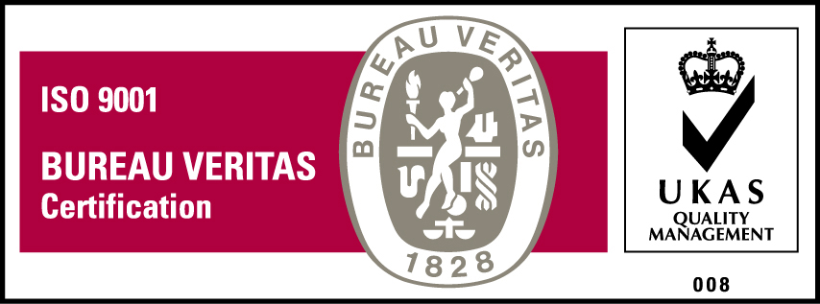***KyU is ISO 9001:2015 Certified***