KIRINYAGA UNIVERSITY

LIBRARY DEPARTMENT

From: Librarian Date: 14th May 2017
To: Deputy Vice Chancellor, ASA

SCHOLARSHIP OPPORTUNITIES---COMPILED BY S.Maina, Librarian
Vocational Education and Training (VET) Scholarships for International Students in Australia, 2018
Australian Government
Application Deadline: June 30
Apply Now
Scholarships for International Students at Hochschule Hof in Germany, 2017-2018
DAAD and Bavarian Ministry of Science, Research and the Arts, Germany
Application Deadline: October 27
Apply Now
International PhD Projects- IPP Summer Call 2017 at Institute of Molecular Biology (IMB) in Germany
Institute of Molecular Biology (IMB) in Germany
Application Deadline: June 16, 2017
Apply Now
ETH Zurich Research Grants in Switzerland, 2017
ETH Zurich
Application Deadline: September 1
Apply Now
University of Auckland RMLA Masters Scholarships in New Zealand or Overseas, 2017
University of Auckland, New Zealand
Application Deadline: August 1, 2017
Apply Now
24 PhD Scholarships at Doctoral School of Social Sciences, University of Trento in Italy, 2017
University of Trento, Italy
Application Deadline: June 7, 2017
Apply Now
EURIAS Fellowship Programme for International Researchers, 2018-2019
The European Institutes for Advanced Study (EURIAS)
Application Deadline: June 7
Apply Now
PhD Fellowships for Therapeutic Innovations in Africa (CDT-Africa), 2017
World Bank and the Government of Ethiopia
Application Deadline: May 30, 2017
Apply Now
Vice Chancellor and President’s Scholarships for Domestic and International Students at University of South Australia, 2017
University of South Australia
Application Deadline: July 31 each year
Apply Now
Dr Zena Daysh PhD Fellowship in Sustainable Development at University of Waikato in New Zealand, 2017
University of Waikato in New Zealand
Application Deadline: July 15, 2017
Apply Now
School of Communications PhD Scholarships for International Students at Dublin City University in Ireland, 2017
Dublin City University, Ireland
Application Deadline: June 2, 2017
Apply Now
Campus France Foundation Doctoral Fellowships for Science and Technology for Portuguese in Portugal and Abroad, 2017
Campus France
Application Deadline: Opens in May and September
Apply Now
Scholarships for Tanzanian Students in France, 2017
Embassy of France to Tanzania
Application Deadline: May 28, 2017
Apply Now
UTokyo-TOYOTA Study Abroad Research Scholarships in Artificial Intelligence, 2017
University of Tokyo, Japan
Application Deadline: June 1, 2017
Apply Now
Institute for Advanced Study (IAST) Doctoral Scholarship for International Students in France, 2017
Institute for Advanced Study, France
Application Deadline: May 30, 2017
Apply Now
Richard Plaschka Postdoctoral Fellowships for International Students in Austria, 2017
OeAD
Application Deadline: September 15, 2017
Apply Now
PhD Scholarships in Portable Analytical Separation Technologies at University of Tasmania, Australia
University of Tasmania, Australia
Application Deadline: May 15, 2017
Apply Now
Professional Visits Programme for Bangladeshi Applicants in UK, 2017-2018
British Council
Application Deadline: June 3, 2017
Apply Now
DST-SDC Media Fellowship for Journalists in India, 2017
Department of Science and Technology (DST), Government of India
Application Deadline: May 31, 2017
Apply Now
Science Scholarships for Indian Students at Swansea University in UK, 2017
Swansea University, United Kingdom
Application Deadline: July 2, 2017
Apply Now
Excellence Masters Scholarships for EU and Non-EU Students at University College Cork in Ireland, 2017
University College Cork (UCC) in Ireland
Application Deadline: June 1, 2017
Apply Now
Vice-Chancellor’s Overseas Excellence Scholarships at Royal Agricultural University in UK, 2017-2018
Royal Agricultural University, United Kingdom
Application Deadline: June 15, 2017
Apply Now
CSIR-IGIB Fellowship in Biology for Researchers in India, 2017
CSIR-Institute of Genomics & Integrative Biology (IGIB), India
Application Deadline: May 31, 2017
Apply Now
Master and PhD Grant in Computational Biology at Lille University of Science and Technology in France, 2017
Lille University of Science and Technology, France
Application Deadline: June 30, 2017
Apply Now
Gordon Full or Partial Fees Studentships for International Students at University of Glasgow in UK, 2017
University of Glasgow, United Kingdom
Application Deadline: May 31, 2017
Apply Now
PhD Fellowships at University of Basel in Switzerland, 2017
Swiss National Science Foundation, Switzerland
Application Deadline: May 22, 2017
Apply Now
40 Calouste Gulbenkian Foundation Undergraduate Scholarships for Armenian Students, Abroad, 2017
Calouste Gulbenkian Foundation, Armenia
Application Deadline: May 31, 2017
Apply Now
Dan Walker Journalism Scholarships at University of Sheffield in UK, 2017
University of Sheffield, United Kingdom
Application Deadline: June 26, 2017
Apply Now
CSIRO Postdoctoral Fellowship in Business Processes and Legal Informatics in Australia, 2017
CSIRO, Australia
Application Deadline: June 13, 2017
Apply Now
Bings Scholarship for International Students in New Zealand, 2017
Provided by the income from a bequest made by Mrs Elsie Violet Wells
Application Deadline: October 1
Apply Now
Killam Postdoctoral Research Fellowship for Canadian and International Scholars, 2017
University of British Columbia, Canada
Application Deadline: November 17, 2017
Apply Now
Academic Boarding Scholarships at Assumption College Kilmore in Australia, 2017
Assumption College, Australia
Application Deadline: August 11, 2017
Apply Now
Cornell University Free Online Course on Structuring Business Agreements for Success
Cornell University
Course Starts on May 23, 2017
Apply Now
Tags: 2017, edX, International, Law, University MOOC
Brown University Free Online Course on Ethics of Memory
Philosophy & Ethics
Course Starts on July 11, 2017
Apply Now
Tags: 2017, edX, International, Philosophy & Ethics, University MOOC
Free Online Course on Digital Manufacturing for Industrial Design
Delft University of Technology
Course Starts on June 6, 2017
Apply Now
Tags: 2017, edX, International, online course, University MOOC
Free Online Course on Strategic Applications of IT Project & Program Management
University of Washington
Course Starts on May 15, 2017
Apply Now
Tags: 2017, Business & Management, edX, International, University MOOC
Free Online Course on Introduction to Philosophy: God, Knowledge and Consciousness
Massachusetts Institute of Technology
Course Starts on June 20, 2017
Apply Now
Tags: 2017, edX, International, University MOOC
Free Online Course to Learn Norwegian Language
University of Oslo
Course starts on May 15, 2017
Apply Now
Tags: 2017, International, Language, May Courses, online course, University MOOC
Lund University Free Online Writing Courses
Lund University
Course Starts on May 29, 2017
Apply Now
Tags: Coursera, English, International, March Courses, online course, University MOOC, Writing

Stephen Maina
Librarian

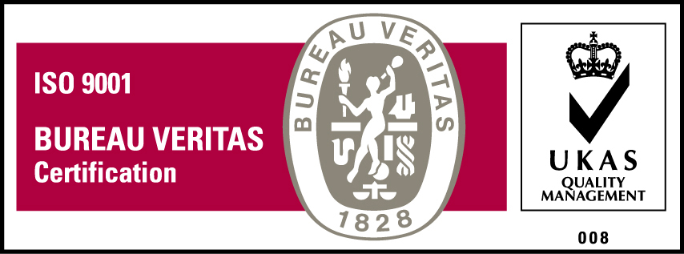
KyU is ISO 9001:2008 Certified

