|  |  |  |  |  |
| --- | --- | --- | --- | --- |
| |  |  |  |  | | --- | --- | --- | --- | | **KIRINYAGA UNIVERSITY**  **SCHOLARSHIP OPPORTUNITIES**   |  |  |  | | --- | --- | --- | | |  | | --- | | HEARD PhD Research Scholarship at University of KwaZulu-Natal in South Africa, 2017-2018 | | HEARD PhD Research Scholarship at University of KwaZulu-Natal in South Africa, 2017-2018 AddThis Sharing Buttons  Share to FacebookFacebookShare to WhatsAppWhatsAppShare to TwitterTwitterShare to LinkedInLinkedInShare to EmailEmail  Sponsored Links  Applications are invited for six full-time HEARD PhD Research Scholarship at the University of KwaZulu-Natal in South Africa. Citizens of all African countries are eligible to apply for this scholarship programme.  The aim of our PhD programme is to produce expertly qualified graduates to advise or to be part of influential policy-making or programme implementing entities in Africa.  The University of KwaZulu-Natal or UKZN is a university with five campuses in the province of KwaZulu-Natal in South Africa. It was formed on 1 January 2004 after the merger between the University of Natal and the University of Durban-Westville.  **Course Level:** Scholarships are available to pursue PhD programme.  **Study Subject:** Six full-time PhD scholarships are available to students conducting research in one of the following areas:   * Health Systems Strengthening * Health Economics * Health Financing * Unsafe Abortions * Contraception * Universal Health Care Financing * Gender-based Violence   **Scholarship Award:** Scholarship offers:   * The scholarship will commence in February 2018. * The value of each scholarship is R 600, 000. It will be paid in equal tranches over three years. * Tranche payments will be conditional on research progress * Successful candidates are required to be based in Durban, South Africa, for the duration of the scholarship, with the exception of the time during which they may undertake field research elsewhere.   **Number of Scholarships:** Six full-time PhD scholarships will be awarded.  **Scholarship can be taken in** Africa  **Eligibility:** The following criteria must be met in order for applicants to be eligible for the scholarship:   * Applications are invited from citizens of all African countries. * Female candidates and, in the case of South Africa, those from previously disadvantaged backgrounds, are especially encouraged to apply.   **Nationality:** Citizens of all African countries ( Algeria, Angola, Benin, Botswana, [Burkina Faso,](http://scholarship-positions.com/burkina-faso-scholarships/2012/11/06/)Burundi, Cameroon, Cape Verde, Central African Republic, Chad, Comoros, Ivory Coast, Djibouti, Egypt, Equatorial Guinea, Eritrea, Ethiopia, Gabon, Gambia, Ghana, Guinea, Guinea-Bissau, Kenya, Lesotho, Liberia, Libya, Madagascar, Malawi, Mali, Mauritania, Mauritius, Morocco, Mozambique, Namibia, Niger, [Nigeria](http://scholarship-positions.com/scholarships-for-nigerian-students-in-nigeria-and-abroad/), Republic of the Congo[, Rwanda](http://scholarship-positions.com/category/africa-scholarships/rwanda-scholarships/), Sao Tome and Principe, [Senegal,](http://scholarship-positions.com/category/africa-scholarships/senegal-scholarships/) Seychelles, Sierra Leone, [Somalia,](http://scholarship-positions.com/category/africa-scholarships/somalia-scholarships/)South Africa, Sudan, Swaziland, Tanzania, Togo, Tunisia, Uganda, Western Sahara, Zambia and  [Zimbabwe](http://scholarship-positions.com/scholarships-for-zimbabweans/2012/09/22/)) are eligible to apply for this scholarship programme.  **College Admission Requirement**  Entrance Requirements: Applicants must have their previous degree.  English Language Requirements: Applicants whose first language is not English are usually required to provide evidence of proficiency in English at the higher level required by the University | | | |

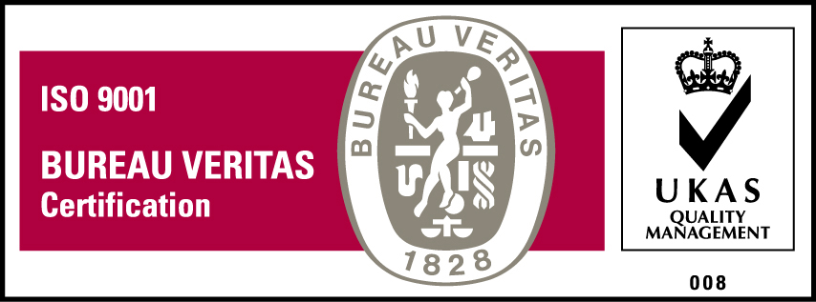***KyU is ISO 9001:2015 Certified***