KIRINYAGA UNIVERSITY

SCHOLARSHIP OPPORTUNITIES

Chinese Government Scholarship-Bilateral Program 2017
Chinese Government Scholarship-Bilateral Program for International Students in China, 2017
Chinese Government
Application Deadline: April, 2017
Apply Now
International Scholarships for Doctoral, Master’s and Undergraduate Students in China, 2017
Xiamen University, China
Application Deadline: April 30, 2017
Apply Now
Macquarie University Vice-Chancellor’s Scholarships for International Students in Australia, 2017
Macquarie University, Australia
Application Deadline: June 30, 2017
Apply Now
Deakin University Online Course to Become Career Smart
Deakin University, Australia
Course starts on March 6, 2017
Apply Now
Many Languages, One World Student Essay Contest and Global Youth Forum in USA, 2017
Many Languages, One World
Application Deadline: March 16, 2017
Apply Now
International Postgraduate Research Studentship (IPRS) at Murdoch University in Australia, 2017
Murdoch University, Australia
Application Deadline: September 30, 2017
Apply Now
20 ICFO International PhD Fellowships Program in Spain, 2017
ICFO, Spain
Application Deadline: March 26, 2017
Apply Now
60 Vice-Chancellor’s International Scholarships in UK, 2017-2018
University of Essex, United Kingdom
Application Deadline: July 31, 2017
Apply Now
30 International PhD Scholarships at Sheffield Hallam University in UK, 2017
Sheffield Hallam University, United Kingdom
Application Deadline: February 24, 2017
Apply Now
Free Online Course on Introduction to Credit Risk Management
Delft University of Technology
Self-Paced
Apply Now
BACS-Taiwan Huayu Enrichment Scholarships for International Students in Taiwan, 2017-2018
Ministry of Education, Republic of China (Taiwan)
Application Deadline: March 31, 2017
Apply Now
President’s Scholarships for Irish Students at Waterford Institute of Technology, 2017
Waterford Institute of Technology, Ireland
Application Deadline: March 20, 2017
Apply Now
FUB offers 15 Postdoctoral Fellowships for International Students, Germany 2017
Free University in Berlin, Germany
Application Deadline: March 15, 2017
Apply Now
Latvian Government Study Scholarships for International Students in Latvia, 2017-2018
Latvian Government
Application Deadline: April 1, 2017
Apply Now
2017 Rotary Scholarships for Water and Sanitation Professionals, Netherlands
Rotary and the UNESCO-IHE Institute for Water Education
Application Deadline: June, 15 2017
Apply Now
Israeli Government Scholarships for Foreign Students, 2017-2018
Israeli Government
Application Deadline: November 30, 2017
Apply Now
Scottish Alliance for Geosciences, Environment and Society Scholarships for International Students in UK, 2017
University of Dundee ,UK
Application Deadline: February 10, 2017
Apply Now
AIMS Postdoctoral Fellowship in Data Science for African Applicants in South Africa, 2017
The African Institute for Mathematical Sciences (AIMS), South Africa
Application Deadline: February 15, 2017
Apply Now
Research Training Scholarships for International Students at Flinders University in Australia, 2017
Flinders University, Austarlia
Application Deadline: August, 14, 2017
Apply Now
NCUK Anniversary Scholarships for International Students in UK, 2017
University of Kent, United Kingdom
Application Deadline: May 31, 2017
Apply Now
International Max Planck Research School for Global Biogeochemical Cycles (IMPRS-gBGC) PhD Program in Germany, 2017
Friedrich Schiller University Jena, the Max Planck Institute for Biogeochemistry
Application Deadline: March 15, 2017
Apply Now
St Mary’s University Twickenham, London International Student Scholarships in UK, 2017-2018
St Mary’s University, United kingdom
Application Deadline: May 21, 2017
Apply Now
China Scholarship Council (CSC) PhD Scholarship Scheme at University of Hull in UK, 2017
The University of Hull ,UK
Application Deadline: February, 15, 2017
Apply Now
ZEIT-Stiftung BA Scholarships in Humanities at U.S. University, 2017
Arnold Heidsieck Scholarship Fund
Application Deadline: March 31, 2017
Apply Now
Full time MBA Scholarships at University of Reading in UK, 2017
Henley Business School, United Kingdom
Application Deadline: June 30, 2017
Apply Now
PhD Research Fellowship in Mantle Geodynamics at University of Oslo in Norway, 2017
University of Oslo, Norway
Application Deadline: March 1, 2017
Apply Now
NAHSSS Allied Health Undergraduate (Entry Level) Scholarships in Australia, 2017
Commonwealth Department of Health, Australia
Application Deadline: February 27, 2017
Apply Now
Korea New Zealand Agricultural Cooperation Scholarships in New Zealand, 2017
New Zealand Universities and Education New Zealand (ENZ)
Application Deadline: April 28, 2017
Apply Now
Master Scholarships for UK Students at Nottingham Trent University, 2017
Nottingham Trent University, United Kingdom
Application Deadline: February 20, 2017
Apply Now
Full PhD Position in Engineering at University of Bremen in Germany, 2017
University of Bremen, Germany
Application Deadline: February 28, 2017
Apply Now
PhD Scholarship Opportunities with Deakin University in Australia, 2017
Deakin University, Australia
Application Deadline: February 20, 2017
Apply Now
University of Kent Rome Scholarships for Masters Programme in UK, 2017
University of Kent
Application Deadline: May 27, 2017
Apply Now
2018-2019 US Embassy Fulbright Foreign Student Scholarships for South Africans in USA
US Embassy, United States of America
Application Deadline: April 17, 2017
Apply Now
Chancellor’s Masters Scholarships for UK/EU and International Students in UK, 2017
University of Sussex, United Kingdom
Application Deadline: August 1, 2017
Apply Now
Scholarships for Russian Students, 2017
Various
Application Deadline: Various
Apply Now
Free Online Course on Advanced Software Construction in Java
Massachusetts Institute of Technology
Course Starts on February 20, 2017
Apply Now
University of London Online Course on English Common Law
University of London, United Kingdom
Course Starts on February 13, 2017
Apply Now
Niagara Foundation Internship for International Students in USA, 2017
Provided by: Niagara Foundation, Australia
Application Deadline March 15th, 2017
Apply Now
RTC Summer Research Program for Undergraduates in Canada, 2017
Provided by: The Lunenfeld-Tanenbaum Research Institute, Canada
Application Deadline February 28, 2017
Apply Now
Campus France Charpak Research Internship Program in France, 2017
Provided by: Campus France
Application Deadline February 24, 2017
Apply Now
Voices of Youth Blogging Internships for International Applicants, 2017
Provided by: Voices of Youth
Application Deadline February 10, 2017
Apply Now

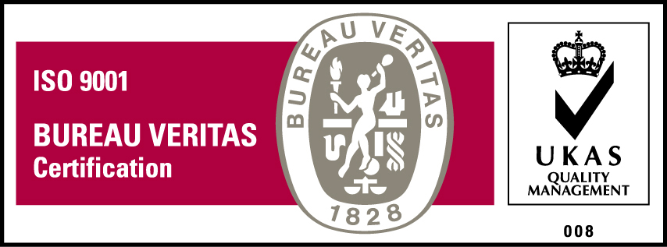
KyU is ISO 9001:2008 Certified

